

**Department of Computer Science and Technology**

**106408 – Artificial Intelligence and Expert Systems**

**Project Proposal on**

# AI in Human Resource Management

**Semester:**​ 5​th

**Program:**​ MCS

## NAME

**Jazib Bilal 10328**

**Arsalan Ullah Khan 10439**

**Submitted to:**​ Sir Siraj Munir

### PROPOSAL

Artificial Intelligence (AI) is the branch of computer sciences that emphasizes the development of intelligence machines, thinking and working like humans. For example, speech recognition, problem solving, learning and planning.

The HR professionals today are focusing to optimize the combination of human and automated work to gain a simple, seamless, and intuitive work environment. It provides them time for creativity, intelligence, and empathy to deliver an enhanced candidate and employee experience.

In this project, we will discuss how principles of AI can be applied on an HRMS used for HRM application. This project will use AI on multiple entities like employee details, payroll, leaves management, helpdesk, performance review, official letters, training etc.

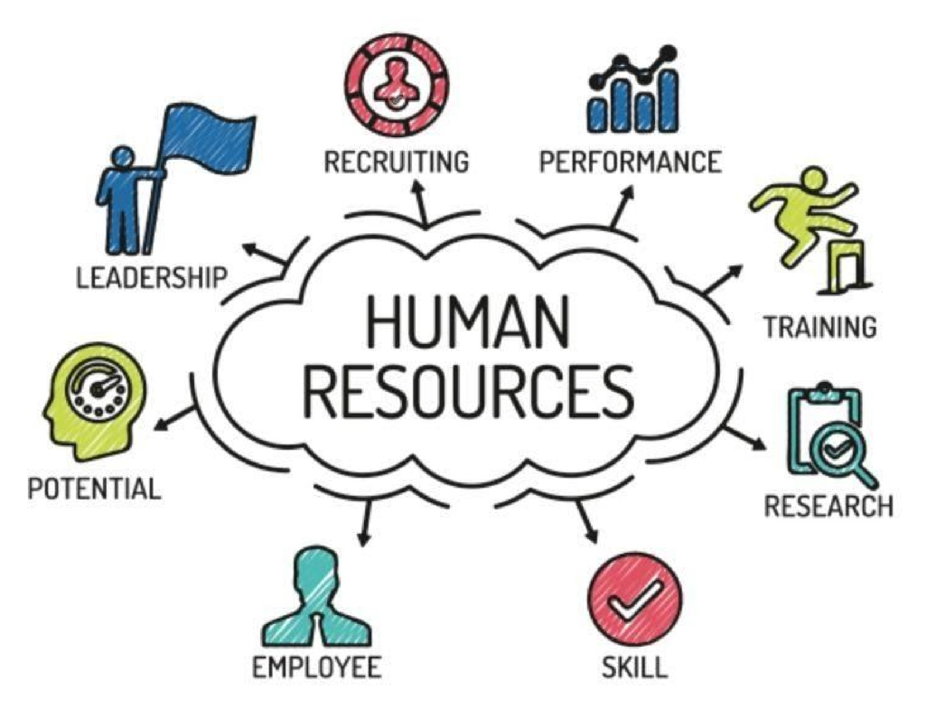

### PROBLEM

Lack of communication with the HR department is the main cause of that the users are mostly unaware of the rights and facilities given by the corporation. An AI based HRMS is the solution to avoid these type of issues and facilitate user about their payroll, their upcoming appraisal, key performance indicators which will help them achieve the promotions, their leave balance and company policies to avail leave types, etc.

### DESIGN

We will design a login page, which will access the database through employee id and a unique password given to user. After successful login, user will now able to access mention below tabs.

|  |  |
| --- | --- |
| **User Info** | Name |
| Employee ID |
| Designation |
| Department |
| **Payroll** | Payroll Slab |
| Current Salary |
| **Projects** | Upcoming Projects |
| Ongoing Projects |
| Finished Projects |
| **Key Performance Indicator** | KPI Slabs |
| Earned KPI |
| **Leave Management** | Leave Types |
| Leave Given |
| Available Leaves |

Each designation of employ have a dedicated basic payroll slab. Payroll will be increased (appraisal) automatically based on key performance indicators, KPI is equally distributed on the number of completion of projects. Leave management system will manually ask for medical or casual leave and in case of more than 2, it will automatically assign it in the category of annual leaves.

### WEEKLY DISTRIBUTION OF WORK

Week 1: Create GitHub ID, Organization, Repository

Week 2: Proposal on Project

Week 3: Searching and Start template design.

Week 4: Designing project

Week 5: Start coding

Week 6: Start coding

Week 7: Apply AI Tree Algorithm

Week 8: Coding

### RESULTS

This basic application can deploy in any organization and will reduce the user’s interaction with HR department and saves time of both along with a complete and 24/7 solution of users personal HR based information.

### PROJECT LINK

<https://github.com/jazibilal/Jazib---AI>